Visual-Auditory-Kinaesthetic (VAK) Model

If you find Honey & Mumford’s learning styles all a bit too much, the VAK model is much easier to understand and apply in practice. VAK was a model originally devised in the 1920s to help teach dyslexic children but its wider applicability and relevance is now well established. VAK questionnaires can be found freely on the internet if you fancy finding out more about yourself.

The model is based on our senses: that we represent information in terms of three modalities – visual, auditory or kinaesthesia. Each of us has all three representation systems but usually one dominates; some people may be evenly balanced in all three.

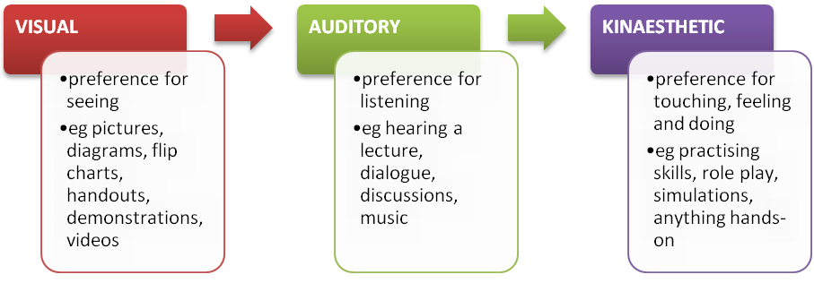

How Can I Assess Someone Without A Questionnaire?
Well, now you know the definitions from the diagram above, you can have a rough guess. This usually works okay if you know the person well.
Otherwise, you could do a couple of things:

- Listen to how they speak:

Visual | Auditory | Kinaesthetic
Often say:  ‘I see what you mean’  ‘Can you show me how..’  ‘Look, this is how you...’  ‘That seems great’ | Often say:  ‘I hear what you’re saying’  ‘Tell me .....’  ‘Listen, this is how you...’  ‘That sounds good’ | Often say:  ‘I know how you feel’  ‘Can I have a go’  ‘Why don’t you have a go...’  ‘I’d feel happy with that’

- Ask them some test questions:

Spelling: If I was to ask you to spell a word would you  - try to picture the word in your mind (V)  - try to sound out the word, or (A)  - write it down to see if it feels right (K) | Concentration: If you are studying or watching a TV programme that you have been looking forward to, which would you become distracted by  - untidiness/movement (V)  - by sounds/noises or (A)  - only if there was activity around you (K)
Meeting someone again: If you met someone that you had previously met a while back do you  - forget names to remember faces (V)  - forget faces but remember names or (A)  - remember best what you did together (K) | Contacting people on business: If you’re planning a meeting with a friendly work colleague would you prefer  - meeting face-to-face (V)  - talking on the telephone or (A)  - doing some activity (like walking) and discussing at the same time (K)
Reading: When reading a novel do you prefer  - descriptive scenes & pause to imagine them (V)  - reading a dialogue or conversation between people and hearing the characters talk (A)  - action stories or don't prefer to read at all (K) | Putting something together: If I ask you to put a small table together would you  - like to see the directions and pictures first (V)  - prefer me to tell you how to do, or (A)  - just get on with it; try to figure it out yourself (K)
Help with a computer: If you need help with a computer application would you prefer to
- see pictures and diagrams (V)
- call the help desk/neighbour/friend/shout at the computer or (A)
- keep trying until you succeed (K)

Now, which was the commonest type of reply – V, A or K?

How to Use The Model
- Use learning methods that match the learner’s preferred style e.g. visual media for visual learners, role play with kinaesthetics etc.
- Instantaneously build rapport with a learner by ‘mirroring’ the style they are displaying e.g. using the same verbs in their speech
- Optimising learning and memorising: Some say that you can optimise learning and memory if you present each key learning point in all three modalities. In a group you’d use all methodologies representing the three modalities anyway to cover the diversity within the audience. But you can extend this further by presenting each learning point in three different modal ways. A lot of schools for children do this these days and there is no reason why the same should not be applied to teaching adults.

References
- Honey P and Mumford A. The Manual of Learning Styles Maidenhead: Peter Honey, 1986

